Dearest Fr. FORTUNATO,
“Glory to God in the highest,
And on earth peace among men
with whom he is pleased!” (Lk 2:14).
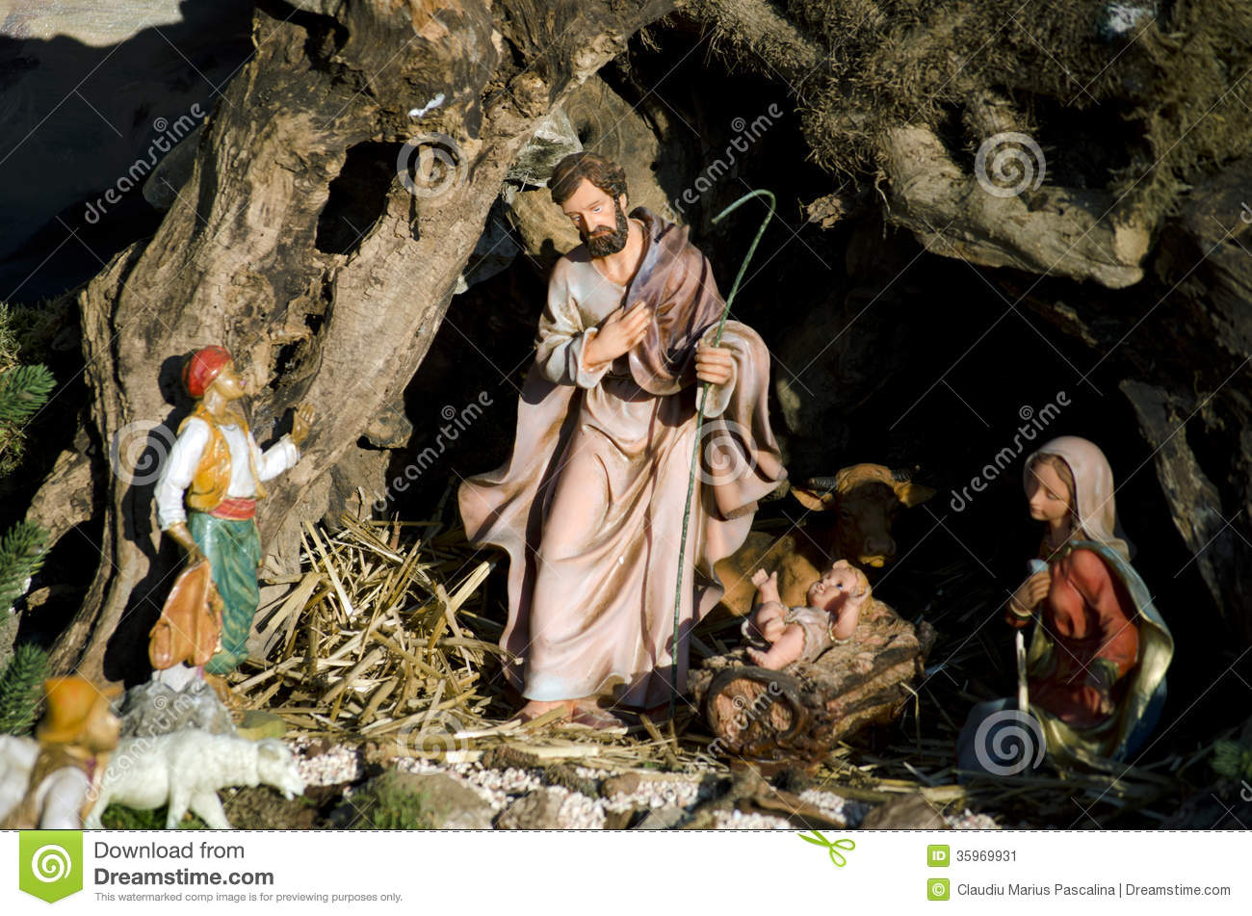
As we joyfully celebrate the Birth of Our savior Jesus Christ, I wish you all the blessings of this glorious event.
May THIS TIME OF GREAT LOVE, PROFOUND JOY AND INNER PEACE, bring us DEEP LOVE, RENEWED JOY AND ASSURED PEACE in CHILD JESUS and let it EMANATE TO OTHERS THROUGH OUR LIFE AND RESPONSIBILITIES.
May you have a grace filled celebration at CHRISTMAS and Bright days ahead in the New Year!

With love and Prayer,
Fr. Varghese Panickassery rcj

